

|  |
| --- |
| *BS Cyber Security Department AU* |

|  |  |
| --- | --- |
| **Registration ID** | **233026** |
| **Submitted By** | **Muhammad Sohaib Rafiq** |
| **Submitted To** | **Iram Fatima Hashmi** |
| **Date of Submission** | **03/27/2024** |
| **Lab NO.** | **6** |
| **Subject** | **NS LAB** |

***Lab Tasks***

***Perform a DoS Attack (SYN Flooding) on a Target Host using***

***Metasploit***

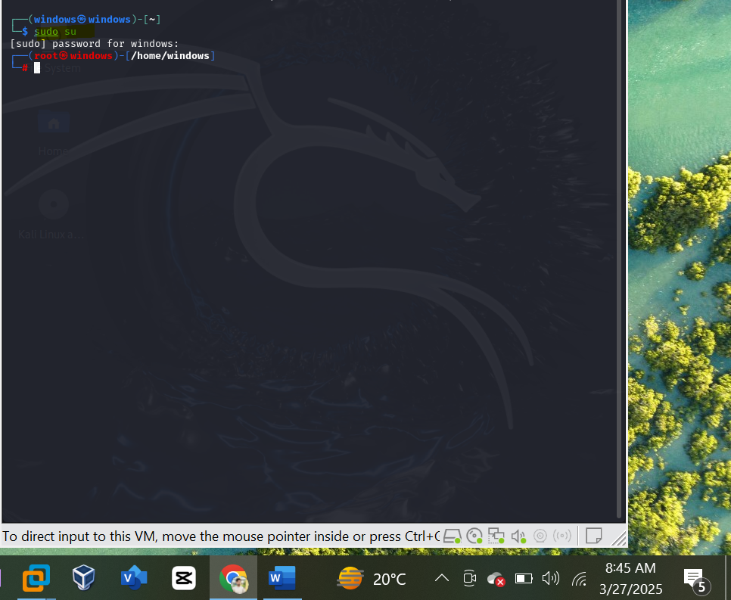

***7. First, detemune whether port 21 is open or not. This involves using***

***Nmap to determine the state of the port.***

***Target ip address:***

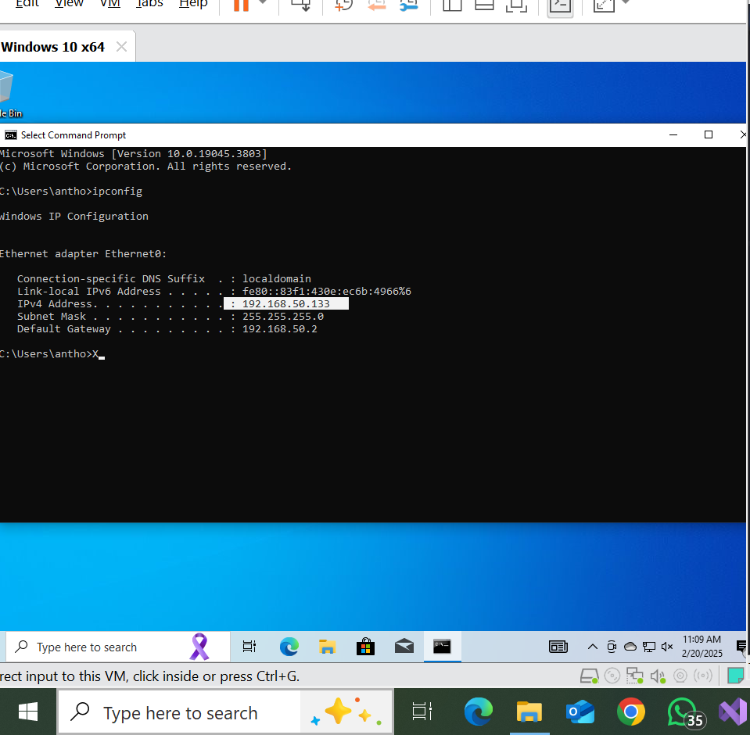

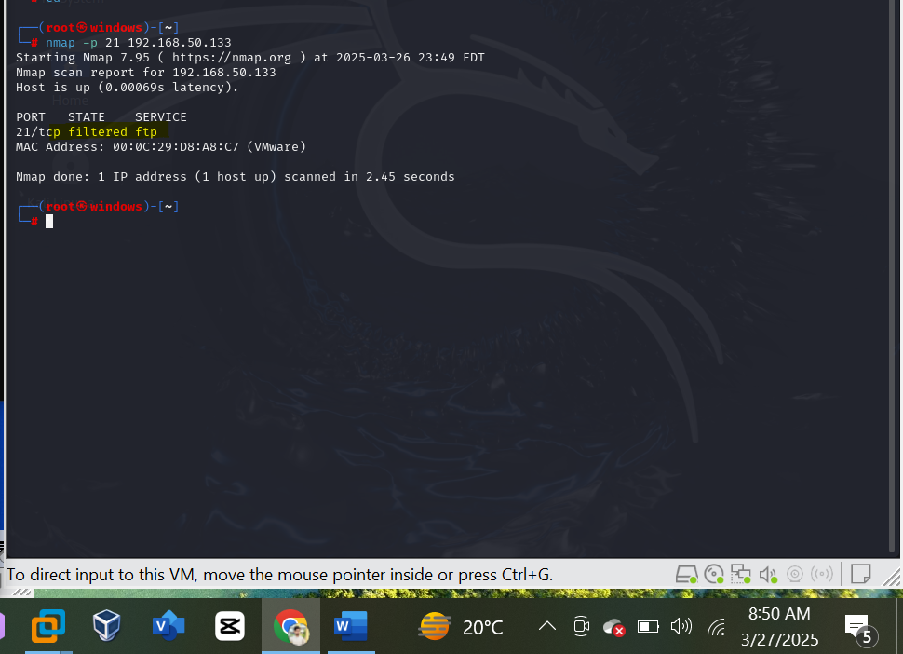

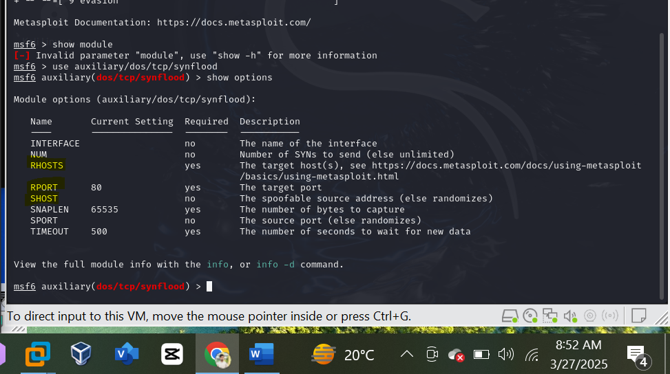

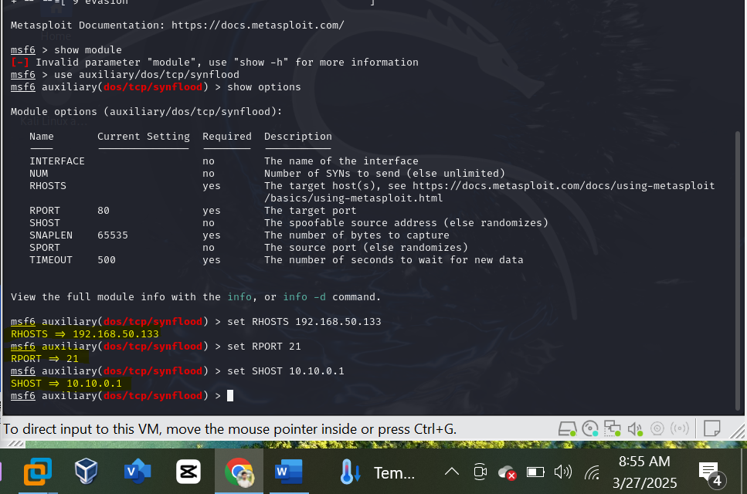

***Now:***

***When I entered the exploit. The synflood dos attacks starts.***

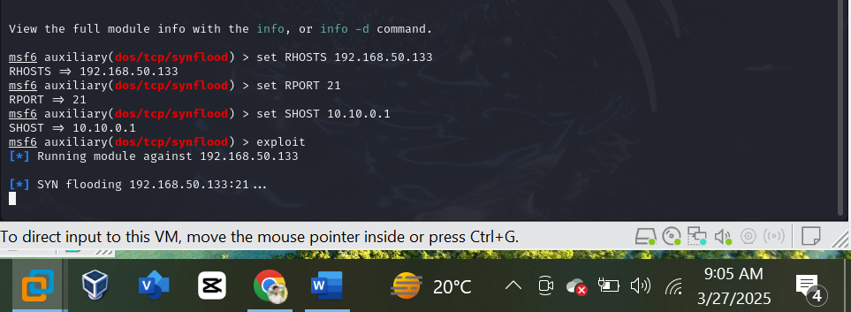

***Capturing the traffic in wireshark from the host:***

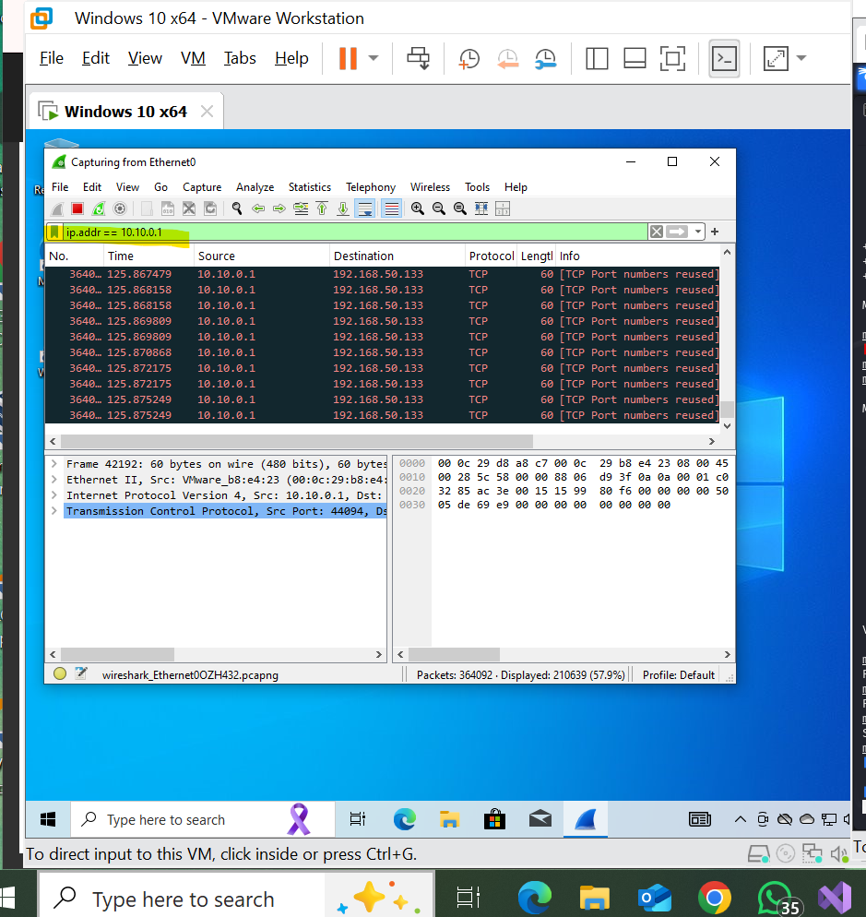

***Note: our dos attack only target the port 21 i.e FTP service as the attack on just one port but It uses the system resources too much as shown below:***

